Hill Elementary Tree Key

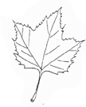 | Sycamore  - Leaf: looks like a hand (like a maple leaf)  - Bark: rough and peeling, like it has a sunburn
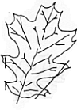 | Oak  - Leaf: long, has lobes  - White Oak = rounded lobes  - Red Oak = pointed lobes
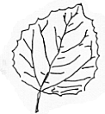 | Aspen  - Leaf: oval-shaped, has serrated (jagged) edges
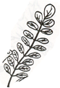 | Locust  - compound leaves (many small leaflets) - like a feather
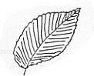 | Elm  - Leaf: oval-shaped, very rough

